**Pre-Submission Seminar**

**Synopsis of the Thesis**

**A NOVEL APPROACH FOR EFFICIENT HANDOFF MANAGEMENT IN HETEROGENEOUS NETWORKS**

**Submitted**

**In the partial fulfillment of the requirements**

**For the award of the degree of**

**DOCTOR OF PHILOSOPHY**

**in**

**ELECTRONICS AND COMMUNICATIONS ENGINEERING**

***by***

**KIRAN MANNEM**

**[ Reg. No. 15PH0421]**

***Under the guidance of***

**Dr. P. NAGESWARA RAO & Dr. S. CHANDRA MOHAN REDDY**

****

**RESEARCH AND DEVELOPMENT**

**JAWAHARLAL NEHRU TECHNOLOGICAL UNIVERSITY ANANTAPUR**

**ANANTHAPURAMU - 515002 (A.P) INDIA**

**JULY – 2021**

**ABSTRACT**

Long-Term Evolution (LTE) is a standard for wireless broadband communication for mobile devices and data terminals. LTE is the evolution of the 3G to 4G wireless networks and provides high-speed data transfer rates and low-latency communication for applications such as streaming video, online gaming, and cloud computing. This wireless network, referred to as a heterogeneous network (HetNet), uses multiple types of access nodes, such as macrocells, small cells, and Distributed Antenna Systems (DAS), to provide coverage and capacity over a large area.

In LTE HetNets, macrocells are the primary network nodes that provide coverage over a wide area, while small cells, such as femtocells, picocells, and microcells, are used to provide coverage in areas with high user density or poor signal quality. Small cells are typically low-power and have a limited coverage range, but they can provide higher data rates and better signal quality compared to macrocells.

The deployment of small cells in LTE HetNets allows for more efficient use of the available spectrum and can help to reduce congestion and improve network performance in high traffic areas. This strategy aids in preserving optimal coverage and capacity across both the current 4G Long-Term Evolution networks and the developing 5G networks.

However, the management of HetNets can be more complex than traditional cellular networks, as the network must be able to dynamically allocate resources and manage Handoffs between different types of access nodes to ensure seamless connectivity for users. So, efficient HandOff (HO) mechanisms are essential for ensuring seamless connectivity and uninterrupted service delivery.

The present research focuses on selecting the ideal target cell for Handoff management. The LTE standard is modeled on a network architecture to test the proposed method. Regression Heuristics Quality Metrics (RHQM), Multi-Objective Artificial Flora (MOAF), and Kinetic Gas Molecular Optimization (KGMO) methods are employed in this research to achieve its goal. The simulation analysis scaled the capability of the proposed approaches by comparing them with existing models under different performance parameters.

Key words: -Handoff (HO), Heterogeneous Networks (HetNets), Long-Term Evolution (LTE), Throughput, Regression Heuristics Quality Metrics (RHQM) Multi-Objective Artificial Flora (MOAF) Algorithm, Kinetic Gas Molecular Optimization (KGMO).

**CHAPTER 1**

**INTRODUCTION**

**1.1 Overview:**

Wireless communication networks are the most critical element in the global Information and Communication Technologies (ICT). Wireless Communication network technology is one of the fastest growing and most dynamic sectors in the world. It has become an essential part of modern life and is used in various applications, such as mobile phones, Wi-Fi, Bluetooth, GPS, satellite communication, and many more. It has revolutionized the way people communicate, work, and access information. Cellular communication is a type of wireless communication that uses a network of cells to provide coverage to a large geographical area. Each cell is equipped with a base station that transmits and receives signals to and from mobile devices, such as smartphones and tablets. Overall, cellular communication has revolutionized the way people communicate and access information, providing ubiquitous connectivity and enabling new applications and services that were not possible before.

Since the mobile UE has become a part of daily life, mobile communications have expanded and demand has grown in areas like data traffic and speed. In earlier decades, there were more traditional mobile networks. For instance, Bell Lab established the Advanced Mobile Phone System (AMPS), or 1G, in 1982. Roaming was used to implement the Global System for Mobile Communications (GSM), often known as 2G. Then, in 1999, the Wideband Code Division Multiple Access (WCDMA) or Universal Mobile Telecommunication System (UMTS) (often known as 3G) went into operation. After then, LTE (or 4G) was introduced. The demand, speed, capacity, coverage and Quality of Services (QoS) cannot be satisfied by the 1G, 2G and 3G networks [1]. The LTE has fulfilled the QoS, demand, speed, capacity and coverage. As a result, the mobile communication sector switches to the next generation mobile networks (LTE/LTE-Advanced) [1-3].

A HetNet is a type of wireless network that consists of multiple types of access points with different coverage areas, transmission power, and network architectures. HetNets are designed to improve network capacity, coverage, and quality of service by combining different access technologies and optimizing their use based on the demand and available resources. Mobility management is a main challenge in the evolving multiservice Heterogeneous network. It consists of two components: location management and Handoff management. Location management tracks and locates the Mobile Terminal (MT) for successful information delivery. Handoff management maintains the active connections for roaming MTs as they change their point of attachment to the network [4].

Handoff management is the process by which a mobile node keeps its connection active when it moves from one access point to another. First, the initiation of Handoff is triggered by either the mobile device, or a network agent, or the changing network conditions. Second, is for a new connection generation where the network must find new resources for the Handoff connection and perform any additional routing operations. Finally, data-flow control needs to maintain the delivery of the data from the old connection path to the new connection path according to the agreed upon QoS guarantees [4].

Researchers have traditionally focused on Access Points (AP) or networks that use the same radio technology when examining handover processes. In order to perform a Horizontal HandOver (HHO), the Received Signal Strength (RSS) levels are primarily considered. Whereas Vertical HandOver process (VHO) is more complex in terms of multiple performance factors [5]. Wireless Fidelity (Wi-Fi), Wireless Inter-operability for Microwave Access (WiMAX), LTE, and Long-Term Evolution-Advanced (LTE-A) are all examples of heterogeneous wireless networks that uses VHO. Due to differences in QoS, security, and bandwidth, it is difficult to support HO’s across heterogeneous networks [6]. To address this issue an efficient HO scheme is essential.

A seamless and secure HO is a must in every situation, and that is the fundamental design goal of cellular networks. The HO system for 4G-LTE wireless networks has become more complex because to the potential availability of numerous types of Base Stations (BS). As the system becomes more sophisticated, additional types of BS, like the Home eNodeB (H eNB), are unable to communicate with the serving eNodeB (S eNB) directly. Furthermore, it is discovered that there is a lack of backward security due to the use of key chains in the HO operations [7].

Overall, vertical handover is necessary in heterogeneous networks to provide seamless connectivity, optimize network performance, and improve the user experience. The handover process must be carefully managed to ensure that it does not disrupt the user's communication and that the handover is transparent to the user.

**1.2 Motivation:**

Due to the rapid rise in the number of mobile subscribers, it is essential to boost cellular capacity. Hence, Small cells are regarded as an emerging technology for boosting the potential capacity of cellular networks. Now, as the density of infrastructure increases, (In the context of transition from 4G to 5G) users have many choices for connection. So, Efficient handoff mechanisms are essential for ensuring seamless connectivity and uninterrupted service delivery.

**1.3 Problem Identification**

Wireless communication faces several challenges, such as interference, fading, and limited bandwidth. However, advances in technology have enabled the development of more efficient wireless communication systems that can overcome these challenges and provide reliable and high-speed communication. Also, Cellular networks must provide coverage and capacity over large geographic areas. This can be challenging in rural areas, where population densities are low, and it may not be cost-effective to deploy cellular infrastructure. In urban areas, high-density populations can lead to capacity constraints, requiring network operators to add more base stations and other infrastructure. Additionally, an ultra-densification technique has been introduced to compress the BS coverage and enhance frequency repeatability in order to fulfil the enormous data demands on future cellular networks [8]. Small cells are one such potential new technology that is required to solve this problem. As new cell communication technology, small cells have the potential to boost cellular networks' capacity. Users may have more options for connection as infrastructure density increases. However, making the appropriate selection of a radio access method is an important criterion to ensure network QoS and HO. Hence, designing a systematic radio access selection mechanism for cellular networks is essential [9].

LTE HetNets are a type of wireless network architecture that combines different types of access points to provide increased network capacity and coverage. The main idea behind LTE HetNets is to deploy small cells, such as picocells and femtocells, in addition to traditional macrocells to provide coverage in areas with high demand or poor radio conditions. In an LTE HetNet, small cells are typically deployed in indoor or outdoor areas with high user density, such as shopping malls, train stations, or sports venues.

It has also several challenges, including

Interference Management: HetNets consist of multiple cells with different sizes and transmit powers. Interference between cells can severely degrade the performance of the network. Advanced interference management techniques, such as interference coordination and mitigation, are required to optimize HetNet performance.

Resource Allocation: Resource allocation in HetNets is challenging due to the different coverage areas and user densities of the cells. The base station must intelligently allocate resources to ensure that users in different cells receive sufficient resources to achieve high data rates.

Backhaul Capacity: HetNets require a high-capacity backhaul network to handle the increased data traffic generated by the multiple cells. Providing sufficient backhaul capacity can be challenging, especially in remote areas or densely populated urban areas.

Cell Selection: HetNets require intelligent cell selection algorithms to ensure that users are always connected to the best available cell. This can be challenging in areas with high mobility or when cells have similar coverage areas.

Handover Management: HetNets require intelligent handover management techniques to ensure that users can move seamlessly between cells without experiencing interruptions in service. This requires coordination between different cells and base stations.

As a whole, LTE HetNets present significant technical challenges that must be overcome to ensure reliable and efficient network performance. One of the core criteria for ensuring Quality of Service (QoS) of the network is cell selection in Handoff management.

In summary, The User Equipment (UE) has a number of possibilities for transferring control to the following eNodeB(eNB) in order to maintain QoS on the network, but choosing the best eNB is the key difficulty that depends on the multiple quality factors. Hence, the targeted eNB must be carefully chosen in order to tackle these problems.

**1.4 Research Objective**

The main objective the work is to select target cell under multi objective QoS metrics with minimal process complexity in LTE Heterogeneous cellular network to perform handoff. It is expected to yield best connection by optimizing performance metrics: Throughput, Handover failure rate, Call drop ratio, Call block Ratio.

**1.5 Synopsis outline**

Seven chapters are included in this synopsis, and the contents are organized as follows:

Chapter-1: This chapter deals about basic concepts of wireless and cellular communications including small cells, Handoff, in LTE Heterogeneous networks, The chapter also provides the motivation, problem identification and research objective for the thesis.

Chapter -2: The limits of handoff management for 4G LTE networks to 5G LTE-Advanced networks are addressed in the chapter along with other literature reviews. Review on optimization strategies, including diverging quality measures and the performance factors of the existing models. This chapter also deals about the literature review on mobility management from various research journals and research studies.

Chapter -3: This chapter covers the Regression Heuristic process for choosing the best target cell, which uses a variety of quality indicators. Along with ranking the target cell and estimating the fitness value of the metrics for the target cell, it also deals with estimation of regression heuristics.

Chapter -4: This chapter outlines the system model and discusses several quality measures. The selection of the target eNB by computing the fitness function of the metrics is also described, along with the mathematical modelling of the Multi Objective Artificial Flora method.

Chapter-5: This chapter discusses the operation of the KGMO optimisation algorithm and the heterogeneous network model based on LTE standards. The KGMO optimisation for connecting to the best network is also described.

Chapter-6: The chapter focuses on the results of the RHQM, MOAF and KGMO algorithms. These are compared with existing models. Regression Heuristic methodology was used as a first model to provide the optimum connection management solution and consequently acquire performance metrics. To achieve handoff connection, optimization techniques have been selected as a second and third model with various metrics and simulation settings.

The chapter-7: Summarizes the research findings and draws a conclusion about the choice of target cells based on the RHQM, MOAF, and KGMO methods. The chapter is devoted to discuss the research's result and potential future applications.

**CHAPTER 2**

**LITERATURE SURVEY**

**2.1 Overview:**

Several works have been proposed to perform optimization, mobility management and HO schemes. Most of the works are targeting to reduce the complexity of the technique and improve network stability without affecting performance parameters. This section goes into great length regarding a number of the earlier methods that were suggested for doing optimization, mobility management, and HO schemes.

The optimization handover parameters are discussed utilising the eNB identity construction by Su, Dongming, et al.[10] RSRP has been heavily used for the procedure across the selection of eNB. The study's authors made the assumption that the boundary constraints for eNB do not overlap. The number of carried out transactions and the number of eNB boundaries that UEs cross are taken into consideration in the results.

 In this paper, Komine, T. et al,[11] proposed a cell selection scheme to enhance the performance of HO optimization. In the proposed scheme, both the uplink and downlink channel quality is considered when selecting a suitable reconnected cell. Through the computer simulation, the proposed scheme reduces the HO failure rate and the number of HO failures by 3 percentage points and 38%, respectively, compared to the conventional scheme based solely on downlink channel quality.

 Qian, Cen et al,[12] a novel cell selection strategy is proposed through taking the cell load condition as one selection criterion and applying polling strategy until a proper cell is selected for the RRC connected users and the idle users. Moreover, load balance method is designed to offload the excess traffic to those low-loaded cells, making the system resources to be utilized more abundantly. Qualitatively, this analysis based on an n-dimensional Markov Chain modeling shows that the load balance process can reduce the call outage probability, which is verified by the simulation results. This strategy can bring less new call blocks, less handoff call drops and more balanced resource utilization of different cells.

Amzallag, David et al,[13] presented two different algorithms for cell selection. The first algorithm produces a (1-r)-approximate solution, where a mobile station can be covered simultaneously by more than one base station. The second algorithm produces a 1-r/2-r-approximate solution, while every mobile station is covered by at most one base station. In this, an extensive simulation study demonstrating the benefits of using two algorithms in high-loaded capacity-constrained future 4G networks, compared to currently used methods. Specifically, two algorithms obtain up to 20 percent better usage of the network's capacity, in comparison with the current cell selection algorithms.

Kamal, A., & Mathai,[14] V, proposed a new cell selection method called Network coordinated cell selection (NC) which allow a UE within the RE region to be offloaded to pico cell based on the load of the pico cell and the achievable throughput. Simulation results shows that this method can achieve better performance than conventional Reference Signal Received Power (RSRP) and Cell Range Expansion (CRE) cell selection methods in LTE HetNet.

Wang, Jun, et al,[15] formulated the cell selection problem into a network wide proportional fairness optimization by jointly considering the long term channel condition and load balance in macro-pico coexisted heterogeneous network. Both optimal solution (by dynamic programming) and cost efficient algorithm (greedy heuristics) are proposed. In 3GPP LTE-A heterogeneous network scenario, the system-level performance evaluation shows that, compared with the conventional strongest signal cell selection scheme, the proposed optimized fairness cell selection methods could achieve significant performance gains especially for the cell edge users.

The dynamic cell selection approach that is offered in various proposals was explored by Gao, Yuan, et al., et al.,[16], and a performance analysis at the system level was carried out using an LTE system level simulator. An improved Dynamic coordinated multi-point Cell Selection algorithm is simulated and contrasted with the conventional approach.

Zhu, Pengcheng et al,[17] addresses the design of transmission algorithm of CoMP systems. The authors concentrate on the coordinate multi point reception / transmission (CoMP) technique based on Dynamic Cell Selection (DCS), which delivers significant performance benefit with only minimal information sharing overhead. A minimum SINR based low-complexity BS selection criterion is proposed and evaluated through system level simulations. Simulation results show that the proposed criterion yields good Frame Error Rate (FER) performance.

Feng, Minghai, et al,[18] proposed an enhanced DCS with muting method is to improve the frequency and power efficiency, by using adaptive muting mode selection. Performance evaluation shows the proposed algorithm provide improved cell average throughput gain and cell edge throughput gain respectively compared with conventional DCS schemes.

Hussein, Yaseein Soubhi, et al[19] proposed a novel method called Fuzzy Multiple-Criteria Cell Selection (FMCCS) in this paper. FMCCS considers Resource Block (RB)s utilization and user equipment uplink condition in addition to S-criterion. System analysis demonstrates that FMCCS managed to reduce handover ping-pong and handover failure significantly. This improvement stems from the highly reliable cell-selection technique that leads to increased throughput of the cell with a successful handover. The simulation results show that FMCCS outperforms the conventional and Cell Selection Scheme (CSS) methods.

Goyal, Tanu et al [20] have proposed eNB factors, and UE factors have relied on the handover optimization conditions for the eNB. Towards selecting the eNB and UEs prioritization process, AHP-TOPSIS has relied upon for enhancing the process. The Q-learning process has used for managing the post optimal eNB solution, which leads to the reduction of HOF and HPP effect for comparison, in managing the conventional solutions and towards enhancing the FMCCS as proposed in [26].

Girma, S. T., & Abebe, A. G,[21] proposed handoff algorithm using fuzzy logic based on mobility load balancing. This algorithm is able to balance load of the BTS by handing off some ongoing calls on BTS’s edge of highly loaded BTS to move to overlapping underloaded BTS, such that the coverage area of loaded BTS virtually shrunk towards BTS center of a loaded sector. In case of low load scenarios, the coverage area of a BTS is presumed to be virtually widened to cover up to the partial serving area of neighboring BTS.Simulation shows that new call blocking and handoff blocking using the proposed algorithm are enhanced notably.

Kalbkhani, Hashem, et al,[22] introduces analytical model of cell assignment probability for Mobile Station (MS) moving from the serving macrocell base station to the target femtocell base station in a two-tier cellular network. The analytical and simulation results indicate the efficiency of the proposed handoff algorithm in comparison with the existing algorithms in terms of cell assignment probability, throughput, number of handoffs, and ping-pong rate.

Mamman, M., [23] developed a Call Admission Control (CAC) algorithm for effective HO in both 4G- and 5G- communication networks. The resources are effectively used in 5G networks by admitting new mobile nodes in the environment that uses the threshold values with admission criteria conditions. The MATLAB simulator is used for implementation and tested the effectiveness of CAC by minimizing the probability of call blocking and dropping with high throughput. But the CAC is unable to handle heavy loads in the environment.

The unique approach, which consisted of the integration of dynamic Almost Blank Subframe (ABS) and dynamic CRE, was presented by Lee et al. [24] in accordance with 3GPP R10 eICIC. According to the cell traffic load, the proposed method adjusts the bias value of CRE based on the outcomes of their offloading to a smaller cell, ensuring that users have access to sufficient resources for data transmission. Additionally, the proposed ABS scheme estimated the ABS ratio, which results in the highest system capacity. Offload users always have access to enough resources, which was ensured by the CRE described in the proposed plan. The experimental results showed that the proposed method significantly improved the performance of the framework by eliminating unintended offloading to an overloaded picocell.

The coordinated scheduling was addressed by Ramos-Cantor et al. [25] along with a centralized controller in the LTE-advanced networks' framework with the issue of muting. An effective equivalent integer linear programme reformulation was proposed in order to increase the applicability of the derived method even to very large networks in order to handle the problem in the best possible way. Simulations of medium- to large-size networks were used to examine the performance of the coordinated scheduling strategies that were provided. Because of out-of-cluster interference, the analytical results illustrate the fundamental limitations in cooperation.

Srikantamurthy, et al., [26] developed a unified HO algorithm according to Dynamic Programming of Discrete Stochastic (DPDS). The algorithm considered overall resource utilization, individual impacts of HO on serving and target cells for effective HO process. NS3-GYM simulator is used for implementing the DPDS algorithm, which is readily integrated in legacy networks. However, the presented approach ignored the average user throughput of the cell-edge users and probability of call blocking, in particular in the course of heterogeneous networks.

Tent chaotic map, adaptive inertia weight, and opposition-based learning are three integrated algorithms developed by Manoj and Kumar [27] for the Whale Optimization technique. The simulation results proved that the TAOWOA achieved high throughput, minimized high energy consumption and lowered the HOPP, HOF, probability of call blocking and call dropping. However, the chaotic map is not effective to solve HO problems in heterogeneous networks due to constraints intricacy and limited pertinence.

A. Slalmi, in [28] minimized the high energy consumption and provided high QoS with the development of internet of things by designing the model in CAC environment. Two independent thresholds are used in this work, where current BS is defined by signal strength and it is measured by mobile station. However, the method ignored the call blocking and call dropping metrics, which is an important parameter for HO scheme.

Ye, J. et.al, [29] minimized the energy consumption without giving up the QoS by introducing Deep Reinforcement Learning (DRL) strategy. Actor Critic reinforcement learning is designed to solve the on/off switching problem into decision process of Markov. The deep neural network is additionally introduced to avoid the storage cost of tabular-based approaches and high computation. However, the importance of optimization is not introduced in this work for decision making process.

Purushothaman, et.al, [30] solved the multi-objective parameters such as average area rate, spectral efficiency, user data rate and energy efficiency by introducing the self-organizing particle swarm optimizer (SOMPSO). In order to get the better results, solution vector is selected by fuzzy decision maker. But the proposed model uses the KGMO algorithm for decision making, which is not complicated like fuzzy rules.

Gong, et.al, [31] designed the system model and formulate the optimization problem based on frequency resource and power allocation. This objective leads to extremely high complexity of network. Therefore, PSO based power allocation and subchannel resource allocation scheme are developed. But the proposed research study implements the existing PSO technique for decision making to test the effective of KGMO in terms of various parameter metrics.

Wu, Xuehan, et al, [32] used for multi objective optimization-(MOAF) and compared with PSO. This can be used for multi objective criteria of any field as optimization solution

Alhammadi, Abdulraqeb, et al. [33] proposed, ATO algorithm is based on UE speed and RSRP only. For a seamless connection, and eNB selection multiple parameters to be considered to get optimum solutions. Still, Optimum selection of target eNB is significant

Moein, Sara et al, [34] proposed KGMO algorithm and compared with traditional PSO and GSA to solve optimization problems. KGMO algorithm would be able to improve the performance of most systems that require a solution to optimization problems.

**2.2 Summary:** The suggested work comprised optimization strategies, including diverging quality measures and the performance factors generated from the functional log of the source and target networks, to address the limitations of these modern methodologies.

**CHAPTER 3**

**Handover Decision in LTE & LTE-A based Hetnets using Regression Heuristics of Quality Metrics (RHQM) for Optimal Load Balancing**

**3.1 Overview:**

The importance of load balancing in LTE-A and LTE-based communication networks has increased due to the sharp rise in consumer demand and load needs for user interaction. The existing models of recent past literature have attempted to balancing the load to offer optimum QoS by respective networks. Nevertheless, handoff schemes portrayed or adapted in several existing methods prioritized for balancing load under QoS parameter, which is particular to target network context. This work presented a new handoff scheme for heterogeneous networks, which attains optimum load-balancing under diversified quality factors. The simulation study has measured the proposed model performance by comparing with existing models under distinct performance parameters.

**3.2 Proposed methodology:**

* In order to complete the Handover procedure, the cell needs be marked as optimal.
* It is intended to "select target cell under multi objective QoS metrics with minimal process complexity" when choosing the target cell for the handover procedure.

The performance factors considered are call block ratio, call drop ratio of handoff load, usage ratio of signaling cost, the ratio of handover failure and radio link failure ratio. The following metrics are used to predict the target cell in handover process.

Reference Signal Receiver Power (RSRP): It is a data used for cell reselection and handover decision. It is a value that defines the strength of the specific signal generated in a cell. RSRP has defined as the average of the powers (in Watts) of resource elements (REs) transmitting signals in a predefined bandwidth [36]. For power control calculations, RSRP is important for estimating path loss.

Received Signal Strength Indicator (RSSI): For a defined channel, this value indicates the total power received. It defined as the linear average of the total power received only for Orthogonal Frequency Division Multiplexing (OFDM) symbols bearing reference symbols by the UE from all sources [36].

Reference Signal Received Quality (RSRQ): It is not directly measured from the signal but calculated from measured RSRP and RSSI values. It defined as the ratio between the number of Physical Resource Blocks (PRBs), RSRP and RSSI as detailed in the following (Eq 3.1) [37]:

 (3.1)

These two parameters LTE-A RSRQ and LTE-A RSRP, have used in mobility management operations such as cell selection, cell re-selection, and handover [38].

Signal-to-Interference-and-Noise-Ratio (SINR): This parameter is measured by the user, allowing the choice of the most appropriate Modulation and Coding Scheme (MCS) for the transmission of data. It is calculated on each RB, converted to Channel Quality Indicator (CQI) by the UE, and then reported to the eNB [36]. It expressed according to the following equation; Where S, I and N are respectively the Signal, Interference, and the Noise: (Eq 3.2)

 (3.2)

**3.3 Quality metrics are adopted for selecting optimal Target Cell:**

Radio Resource Availability (RRA) Coefficient: This metric denotes the minimal level of radio resources available at uniform transmission time intervals of the target cell

Guaranteed Bit Rate (GBR) Coefficient: The minimal level of bandwidth available at each transmission time interval available has denoting as guaranteed bit rate coefficient:

Cell Capacity (CC) Coefficient: This metric denotes the minimal number of available E-UTRAN resources during a given threshold of a transmission time interval.

Reference Signal Receiver Power (RSRP) Coefficient: This metric denotes the minimal signal receiving power observed at each threshold of the transmission time interval.

Reference Signal Receiver Quality (RSRQ) Coefficient: This metric denotes the signal receiving quality expected at the given threshold of the transmission time interval.

Received Signal Quality (RSQ) Coefficient: minimal signal quality expecting during the given threshold of the time interval

Cell level Interference (CLI) Coefficient: Minimal interference in transmissions at the given threshold of transmission time intervals.

Cell level throughput (CLT) Coefficient: The minimal throughput guaranteed at divergent time intervals of a given threshold

Handover Failure Rate (HFR): This metric denotes the minimal rate of handover failures at the target cell during the cached transactions handed-over to the corresponding target cell.

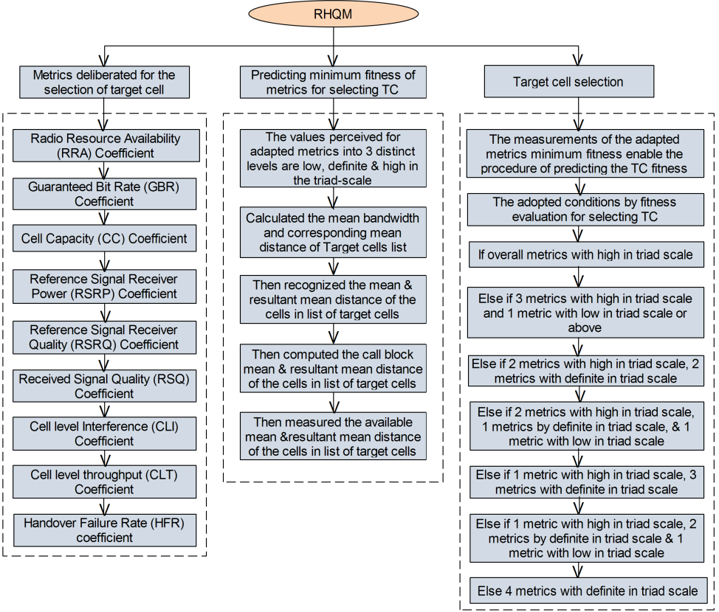

Block diagram of RHQM

The above block diagram shows the procedure for obtaining target cell in which it has order of the quality metrics deliberated for Target Cell (TC) selection, predicting minimum fitness value and adopted conditions by fitness evaluation for selecting TC.

**3.4 Estimation of regression heuristics of metrics as follows:**

|  |  |  |
| --- | --- | --- |
| Find-Regression-Heuristicsbegin | // the function that discovers regression heuristics of the metrics adapted, the set  represents the empirical probabilities of the metric value of the transmission time intervals | |
|  | | // Find the empirical probability of the given metric value of the all transmission time intervals range j=1,2,…, . |
|  | | //Finding the deviation of empirical probability of the metric values. |
|  | | // the absolute distance of the empirical probability and respective deviation of the empirical probability is the lower bound of the metric values |
|  | | // the aggregate of the empirical probability and respective deviation of the empirical probability is the upper bound of the corresponding metric. |
| Return | | // returns the regression heuristics, and respective lower and upper bounds |
| End | |  |

**3.5 Ranking of Target cell is depicted here:**

For each target cell

* + 1. if the expected value of a metric is lesser than the regression heuristic that indicates the lower bound of the metric values, then ranks as 0,
    2. if the expected value of metric is equal to the regression heuristic, then assigns rank 1,
    3. if greater than the regression heuristic, and lesser than the upper bound of the metric value, then assigns rank 2,
    4. or if the expected metric value is greater than the upper bound of the metric value, then rank the target cell as 3for the corresponding metric.

The values perceived for adapted metrics into three distinct levels are low, definite & high in the triad-scale. The criteria used by fitness evaluation to choose the target cell is depicted below:

* If overall metrics with high in triad scale
* Else if three metrics with high in triad scale and one metric with low in triad scale or above
* Else if two metrics with high in triad scale, two metrics with definite in triad scale
* Else if two metrics with high in triad scale, one metrics by definite in triad scale, & 1 metric with low in triad scale
* Else if one metric with high in triad scale, three metrics with definite in triad scale
* Else if one metric with high in triad scale, two metrics by definite in triad scale & 1 metric with low in triad scale,
* Else four metrics with definite in triad scale

**3.6 Predicting Minimum Fitness of Metrics for Selecting TC:**

The prediction of minimum fitness could be carried out using Eq 3.3, Eq 3.4, and Eq3.5.

(3.3)



(3.4)



(3.5)



The above equations have used to calculate the mean bandwidth and correspondingmean distance of Target cells in the list. Here, the depictionsignifies the count of Target cells in the list. The minimum bandwidth fitnessis absolute variance among& its resultant mean distance.



(3.6)



(3.7)



(3.8)



Eq 3.6, Eq 3.7, and Eq 3.8 are used to find the mean& resultant mean distanceof the cells in a list of cells. The depiction ofsignifies several cells in the list. The notationtells minimum fitness of metric signaling cost, which is the absolute variance among& its corresponding.



(3.9)



(3.10)



(3.11)



The Eq 3.9, Eq 3.10, and Eq 3.11 are used to compute the call block mean and the resultant mean distanceof the cells in the list of cells. Here, the depictionindicates several cells in the cells list. The depictionsignifies the minimum fitness of the metric call block ratio, which is the absolute variance among and its resultant.



(3.12)



(3.13)



(3.14)



The Eq 3.12, Eq 3.13, Eq 3.14 are used to compute theavailable mean &resultant mean distanceof the cells in the list of cells. The depictionsignifies the count of cells in the list. The notationis minimum fitness of the available scope, which could be the absolute variance among & its resulting.



**3.7 Target Cell Selection:**

Objective: connecting to best network using regression heuristic and minimum fitness value of Target cells (TC) in the list.

There are nine (9) Quality Metrics for TC selection. Regression Heuristics of each metric is estimated and it returns the regression heuristic, respective lower and upper bounds.

The carrier that initiating the handover process allocates a rank for each neighbor cell, such that each target cell ranked as 1, 2, 3, or 0 for each quality metric adapted.

In this regard each target cell entails divergent ranks for divergent metrics under the expected metric value of the triggered time interval, Fitness function is also estimated for each ranked target cells in terms of performance parameters in order to finalize the target cell towards handover process. Further, the target cells have to sorted in ascending order of the prime metric Handover Failure Rate (HFR), Then selects the target cells in ascending order of their fitness value.

**3.8 Summary:** This work employs a Regression Heuristic approach that uses a number of quality factors to select the optimal target cell. It also deals with the estimate of regression heuristics in addition to ranking the target cell and calculating the fitness value of the metrics for the target cell.

**CHAPTER 4**

**Multi-Objective Artificial Flora Algorithm Based Optimal Handover Scheme for LTE-Advanced Networks**

**4.1 Overview :**

In LTE-AN, an optimal HO scheme is presented in this paper for balancing the load. Before initiating the process of HO, the different parameters that are mentioned in contribution is calculated in each eNB. By considering these parameters as objective function, the selection of target eNB is carried out by the proposed MOAF optimization algorithm.

* As an objective function for selecting the best eNB, the four HO parameters uplink Signal to Interference Plus Noise ratio (SINR), Reference Signal Received Quality (RSRQ), Reference Signal Received Power (RSRP), and fading factor are taken into consideration.
* The target eNB is chosen using the suggested MOAF method, where the fitness function is taken into account as an objective function.
* The effectiveness of this method is assessed using the metrics of HOF, HOPP, call block ratio, and call drop ratio.

**4.2 Description of System model:**

Fig.4.1 presents the system model of the LTE-AN, where UE is used for communication process and controlling the cell phones using eNB in each cell. The UE in a cell transmits a service request to the associated eNB in a cell. based on the service requests received, calculates an eNB cell's load factor. Each eNB in the cell interacts with nearby eNBs using the X2 interface and the cell load level is transmitted between neighboring cells.

For example, load the maximum number of users allowed are four users per cell. However, the central cell, or serving eNB, contains five UEs, so this cell is considered a compound cell. The cell's Serving eNB (SeNB) is unable to provide a new UE service due to the load. So, Target eNB (TeNB) with low load will be selected. To determine the optimal TeNB, the MOAF is provided. The SeNB will give along the service request of the UE to this chosen TeNB.



Fig.4.1**:** System model

The energy verification and the lead time of the signal hysteresis are determined using conventional methods [2-4]. Additionally, various factors are taken into account when choosing the best eNB. The fundamentals of the model are described by the following parameters.

RSRP: It is the total power received from a single resource element of a reference signal. LTE RSRP does not take into account the cyclic prefix and just calculates the usable portion of the OFDMA symbol. In linear units, the average is calculated. A reference point is the UE's antenna connector. The reference signal may be transmitted using either one or both antennas. This is taken into account while measuring RSRP.

RSRQ: RSRQ is a C/I measurement that evaluates the quality of a reference signal that has been received. When RSRP is insufficient to make an accurate handover or cell reselection decision, the RSRQ measurement gives extra information.

(4.1)

SINR: SNIR, which stands for Signal Quantity, Interference, and Noise Quantity, is a crucial RF measurement. When there is no interference, it may also be referred to as SNR. It shows how much the targeted signal is stronger than interference and noise. Its unit is dB. Mathematical it can be express as

 (4.2)

Where, eNB received the power that is denoted as P and noise of background is depicted as N. Besides, interference of upper link over thermal is presented by ITul and the mathematical Eq. (4.3) is used for this calculation.

 (4.3)

Where, ITm represents the macrocell-to-macro-cell interference.

**4.3 Mathematical model of MOAF algorithm:**

The overloaded eNB HOs the user to the target eNB, i.e., minimum HOF, after the HO parameters in each eNB have been determined. The MOAF method, which is worked based on seed propagation and is classified in two forms such as automated and algorithmic, is used to carry out the target eNB selection process ideally in order to improve the process of HO.

The four fundamental components have in AFA: serving eNB, the target eNB, the location and the Euclidian distance. The below section shows the steps followed in the proposed model as:

*eNB Initialization*:Consider an approximate number of true eNBs as with N solutions. The following mathematical equation shows the initialization process:

 (4.4)

where eNBs in the network or solution is depicted as , optimization problem is represented by Q, and is used to represent the actual position of eNBs and here the number of eNB is given by and dimension is given by .

 (4.5)

Where, the region of maximum control is depicted by and sequence of random number between o to 1 is represented by

*Users Behavior*:The users of eNBs are scattered in a circular motion with a radius called the Euclidian distance. The distance of the serving eNB and the target eNB are used for establishing the connection.

 (4.6)

where c1 and c2 are the study coefficients, d2j is the Euclidian distance of the serving eNB, rand (0,1) is the evenly distributed number (0,1) and the target eNB Euclidian distance is depicted by .

New Euclidian distance is

 (4.7)

The constant difference between user and the target eNB is the distance of the new target eNB.

 (4.8)

*Spreading Behavior* of all stake holders

 (4.9)

where, m indicates user, the position of target eNB is represented by , position of serving eNB is depicted by , and Gaussian difference with random number is given as [32].

Fitness: For startup solutions, fitness value is used to identify the optimal solution. The exercise activity is determined according to equation (4.10)

 (4.10)

Here, weight parameters are represented as , which is in the range [0, 1]. The solution with the maximum exercise value is selected as the optimal solution or eNB goal. Otherwise, each solution will be updated until the optimal solution is available.

*Behavior for Selection:* The roulette wheel selection technique, also known as the proportional selection technique, [40] has the primary objective of “accepting as much as possible” to determine target eNB. The survival probability is used to identify the target eNB survival probability by equation (4.11).

 (4.11)

Where, probability of specific is defined as Px(j×m−1). The value of Px must be large for obtaining the optimal local solution. Fmax indicates maximum suitability for eNBs, and F (S’i,j×m) indicates suitability for j-th solution.

*Termination*:The above traits are repeated until the target eNB is selected and the maximum number of iterations is reached.

**4.4 The selection of the target eNB using the MOAF:**

The flow diagram of proposed model is given in Fig.4.2. As a first step, all eNBs are initialized and calculated the distances among users and eNBs. Second step, preparation of the target eNBs, calculate the fitness function based on metrics and survival probability. Third step, if selected eNB not listed, then initialize eNB’s. Fourth step, if selected eNB listed, the user switches from serving to target eNB.



Fig.4.2: The selection of the target eNB using AF’s flow process

**4.5 Summary:** In this study, the target cell will be chosen using a number of objective QoS criteria with minimal processing complexity. The goal eNB is chosen using the suggested Multi-Objective Artificial Flora (MOAF) Algorithm method, with the fitness function taken into account as an objective function.

**CHAPTER 5**

High-Performance Mobility Management Using KGMO in Heterogeneous Network

**5.1 Overview:**

In this work, a new mobility management technique is proposed to perform effective network management in LTE based heterogeneous networks. KGMO optimization technique is used to perform the decision-making using network parameters such as coverage, distance, location and mobility to get handoff information. The following is a description of the work's goals.

* To improve the overall performance of the network while doing the mobility management process
* To maintain stability in throughput and delay while mobility and handover
* To reduce the computational complexity and decision-making time

**5.2 Proposed Methodology:**

* KGMO optimization technique is used to perform the decision-making using network parameters such as coverage, distance, location and mobility to get handoff information.
* Proposed work uses heterogeneous network which is connected in an LTE network
* The number of nodes move to any location within the whole network area
* While moving the user, the user should connect with a nearest router or station that should be selected properly by considering various parameters such as distance, location and mobility.

The proposed method uses high-performance optimization such as KGMO [41] to perform the optimization process for the mobility management. Fig.5.1**.** Shows the network model which is used to code the network architecture. Linear and non-linear network parameters are considered to make mobility management decisions. Fig.5.2. shows the block diagram which is used for the decision-making process. Data collected is pre-processed by using normalization techniques to improve the accuracy of the optimization process. A fitness function is modeled based on the combination of user parameters such as coverage, distance and velocity. A maximum value of fitness is considered as the best fitness value. The network model and functioning of the system are described in the following sections.



Fig.5.1. Network Model

**5.3 Description of Network Model:**

The network model consists of different heterogeneous devices and routers as shown in Fig.5.1. These networks are connected to a core network to form a network model. Each of the individual clusters in this model has a different size in the coverage area depending upon the power of the transmission from the core base station. The number of users in a network keeps changing from time to time and active user rate will also be changing accordingly. Also, the network core has a coverage area for including multiple networks within it. It is responsible for the management and efficient handling of the entire network.

**5.3.1 Functioning of the model:**

The details about the different heterogeneous network information are gathered for pre-processing from the core network. The collected data is considered for preprocessing such as normalization. The normalized data is sent to KGMO to estimate the initial Kinetic Energy (KE) and initial velocity of users. Based on the initial velocity of the users a random particle is generated to calculate the fitness function for the evaluation of the technique. The entire process to yield appropriate fitness function is depicted in Fig.5.2.



Fig. 5.2. Block diagram for optimization technique

Once fitness function is calculated, the best fitness is selected to update the KE and velocity, and consequently generate a new random particle. This process is repeated till the best fitness is obtained. This is performed by KGMO algorithm.

**5.4 Mobility Management using KGMO Optimization:**

The overall process in mobility management consists of nodes deployment, cluster head identification, data collection and a decision-making unit. The Optimization process is depictedinFig.5.3. Initially all the user parameters are read from the network and user data is pre-processed before it is given for the optimization engine. Then the kinetic energy is initialized for every user. Next, the initial fitness function is estimated and the best fitness is arrived after it undergoes number of iterations. The number of iterations depends on time. Upon arriving the best fitness function, then the device will be connected to best network and process stops.



Fig. 5.3. Flowchart for the Optimization process

**5.4.1 Nodes Deployment:**

In order to check the performance of the system nodes are deployed randomly based on the area specified. For simulation purpose the space with the area 50mx50m is considered. Nodes locations (X, Y) are randomly generated to place them in the given area. These coordinates are stored in an array format to deploy the users. These randomly deployed users are assigned with some initial velocity. The cluster head is decided based on the Euclidean distance with respect to other users in the group. Clustering can be performed based on any clustering technique such as Fuzzy c-means (FCM) or K-means technique. In this work, FCM clustering technique is used to perform grouping the users.

**5.4.2 Cluster head identification:**

The next step is to identify Cluster Head (CH). To perform this identification Fuzzy c-means (FCM) clustering is used. The FCM groups the data and generate a centroid value based on the number of clusters. The Cluster Head is located near the centroid value. The center of each cluster can be found using FCM technique using equation (5.1).

(5.1)

where is the center of kth cluster.

Mk Refers to the degree of coefficient for kth cluster.

y is the array index used to access elements in Mk.

d refers to the degree of membership.

Centroid of a cluster is the mean of all points weighted by their degree of cluster network membership. The Euclidean distance between the centroid and user location is given as

(5.2)

Where (cx, cy) are the coordinates of centroid and (, ) are the coordinates of ith user.

After finding the all-Euclidean distances the Cluster Head can be identified by observing the minimum distance. The location of the user which results minimum *di* is nothing but Cluster Head

(5.3)

**5.4.3 Data collection unit:**

These randomly deployed users are assigned with some initial velocity. Then the network collects location of the user along with distance of all users at initial time slot. After time all users may change their locations and the cost function is evaluated based on this updated information for every user in the network. To perform the mobility management process repeatedly, the location information stored in the base station which will be used to update the data.

**5.5 KGMO Engine**

The main objective of KGMO is to estimate best fitness function. The major factor for fitness estimation is the distance between the users in the network from the Cluster Head. From the location of each user, the distance between the cluster head and end-user is calculated. The fitness function is modelled based on the distance, coverage and speed of the device. Let i be the th device coverage with respect to the router distance. And  ­be the velocity of the device with respect to the CH. Here coverage is directly proportional to the mobility factor. But distance and mobility are inversely proportional to the handover process. Hence, to perform the fitness function the reciprocal values of distance and velocity are considered as given in equation (5.4).

(5.4)

Where ci is the coverage area of the cluster, vi is the velocity of the device and the di is the distance of the device from the Cluster Head



Fig. 5.4. Calculating Fitness value between user and CH

**5.5.1Working of Fitness Function:**

To analyze the KGMO, here it is considered with five Cluster Heads in an area 50mX50m square meters and it is assumed that the user ui is moving with a velocity of vi in a distance di having coverage ci with reference to CH. To find out the best connection for the user among five Cluster Heads, the connections are established randomly among all Cluster Heads and the distance is calculated between each user. Based on the distance between each user, moving velocity, and coverage the fitness function is calculated. Here if the coverage is high, distance and velocity are less, then the fitness value is more. Similarly, the random connection is performed between each user and CH to obtain the best fitness value. The maximum value of fitness will be the best fitness value for a particular combination of CH and User. Fig.5.4 depicts the fitness calculation.

**5.6 Mathematical Model for KGMO based Mobility Management:**

Consider a network that has number of users. The position of the user is characterized by

(5.5)

where be the position of user in the cluster head. The moving velocity of user is obtainable by

(5.6)

where denotes the rate of the user in the cluster head. The kinetic energy, in the particular user, is defined as

(5.7)

where is number of total users, is Boltzmann constant, and is the temperature of th user in the cluster head at time . The movement velocity of user is updated by

(5.8)

where for the converging users reduces exponentially over time and is calculated as

(5.9)

The vector be the best previous position of the th user. The position is updated for unit time interval by equation (5.10) This parameter is used to optimize the fitness value for the next iteration

(5.10)

**5.6.1 Decision-Making Unit**

The best fitness for which cluster head to connect with user is found using (5.11)

(5.11)

Where is the current fitness value and is the Previous best, using this fitness value, the user is connected to the best network.

E:\works\GLT_works\Quest\kiran\matlab\results\PSO.tiff

Fig. 5. Number of iteration versus fitness value in KGMO technique

To obtain the best, each iteration is divided into 500 sub iterations, the best value of each sub iteration is stored to get the final optimized value. In this work, 50 iterations are carried out and the fitness plot is shown in the Fig.5.

**5.7 Summary:** In this work, a new mobility management approach is provided to improve the effectiveness of network control in heterogeneous LTE-based networks. The KGMO optimization technique is applied to decision-making for mobility management.

**CHAPTER-6**

**RESULTS AND DISCUSSION**

**6.1 Results of RHQM:**

The experiments have carried using LTE-A & LTE system level simulator [35]. The standards & aspects have given in Table 6.1. Each-reiteration of simulation has approximately executed for 20min, which enables almost 15000 transmission requests.

TABLE 6.1: Aspects used in the Simulation

|  |  |
| --- | --- |
| ***Name of the Aspect*** | ***Configuration*** |
| Properties Service | Average tenure voice call is 30000 ms with an average speed of transmission 18 kbps |
| Cellular frequency radius | 500 meters |
| Reiteration period | 20 minutes |
| Ability of Carrier-frequency | 2.4 GHz |
| Ability of Max-bandwidth | 1.4 MHz |
| Layout measurements of Cellular network | 90 cells |
| Recurrent frequency utilization | 1 |
| Traffic aspects | Haphazardly dispersed in space |
| Deliberated kind of Transmission | Downlink-transmission |
| Handoff aspects | The initiating period is 0.1sec |
| Scheduling aspects | Best suitable, & round robin is the scheduling schemes adapted for frequency & time domains respectively |
| Requests count for one recurrence | 15000 |

The importance of recommended approach known as “Load Balancing by Diversified Quality Factors based Handoff” is evaluated through comparing with other existing models known as “QoS-Based Multi-criteria Handoff Algorithm (QMHA)” [28], & “Analytic Hierarchy Process Technique for Order of Preference by Similarity to Ideal Solution method (AHP-TOPSIS)” [20]. The performance assessment aspects that are adapted are (i) minimum ratio of call block (ii) minimum ratio of handoff failure (iii) minimum call-dropping (iv) minimum radio-link failure & (v) minimum cost of signaling.

**6.1.1 Analysis of Performance:**

The simulation values recorded that perceived for metrics of the performance over every effort of cell distribution aimed at every transmission-request. Here, the ratio of performance metrics value at a constant time could utilize for calculating the proposed model.

To report suggested scheme optimal “RHQM (Handover Decision by Regression Heuristics of Quality Metrics)” aimed at optimum LB, the resultant values for the metrics has compared by other present models called AHP-TOPSIS & QMHA.

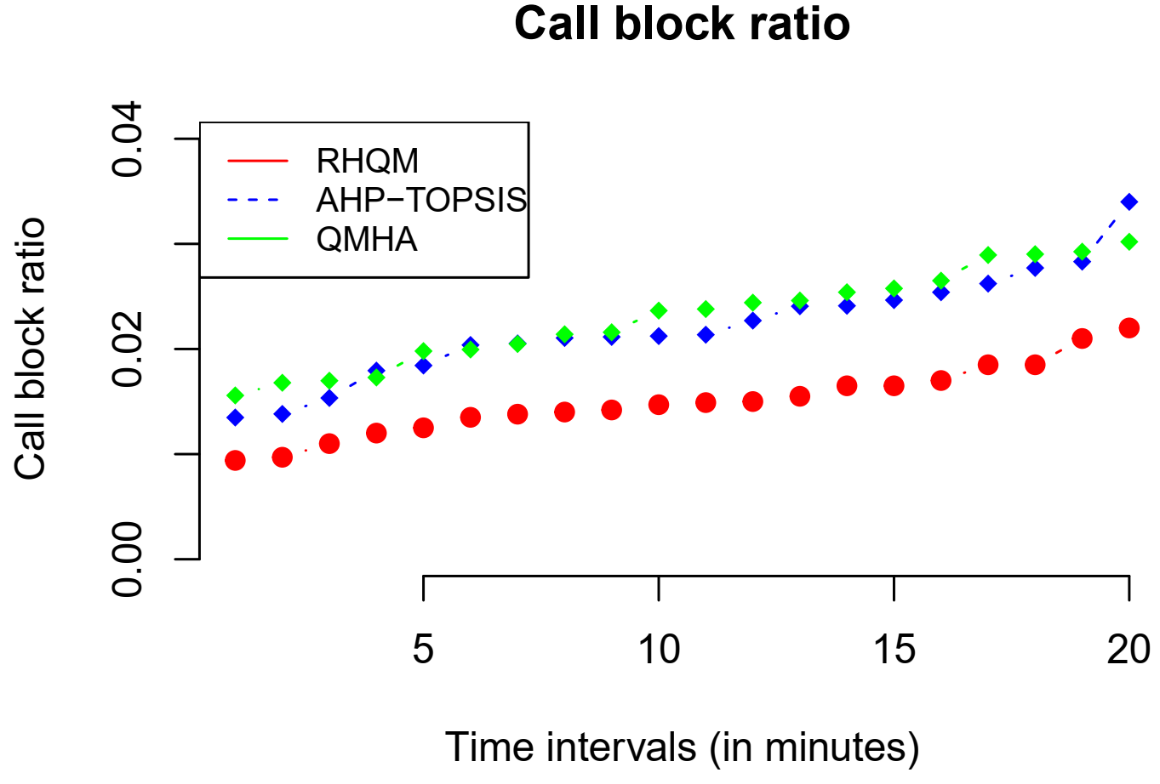

Fig.6.1: The Comparison of CBR (Call Blocking Ratio) Perceived for Contemporary QMHA, AHP-TOPSIS, Methods & Proposed Method RHQM

The CBR perceived for proposed RHQM is less, while compared over the other two methods. The CBR vs. load at distinct periods have noticed for the proposed RHQM method is linear, which is lesser than AHP-TOPSIS & QMHA in respective order (Fig.6.1).

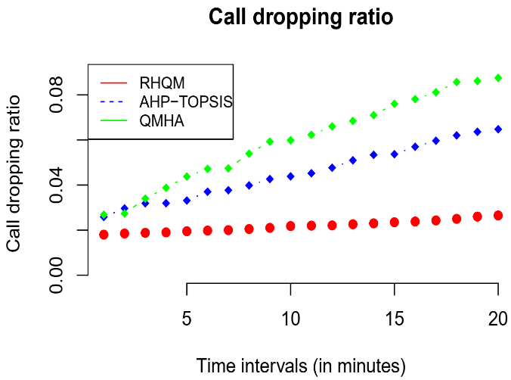

Fig.6.2: The CDR noticed at distinct Time-Intervals

In Fig.6.2, a similar performance exhibited in the call-dropping ratio (CDR). Here, the CDR has attained from empirical study representing that RHQM could be persistent at divergent load intensities over divergent periods. The average CDR noticed for RHQM is lesser than the other two models AHP-TOPSIS & QMHA.

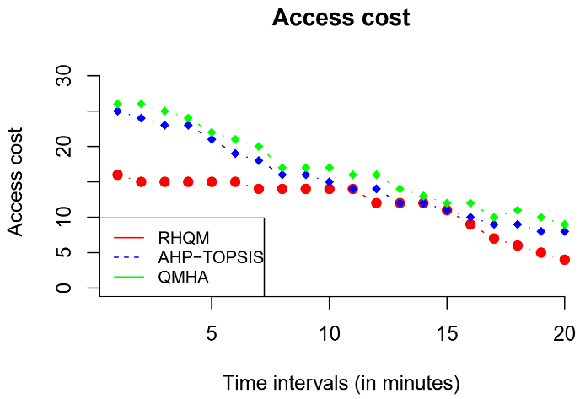

Fig.6.3: Average Costs of Signaling Noticed at distinct Time Intervals

In Fig.6.3, signaling cost noticed for the proposed method RHQM and contemporary models RHQM & AHP-TOPSIS is compared. The simulation outcomes indicate that signaling-cost noticed at RHQM could be stable & minimum, whereas the AHP-TOPSIS & QMHA exhibited that signaling-cost could be maximum at early stage dispersed to low by finishing time of experiment that is unbalanced & maximum when it has compared with signaling-cost noticed at RHQM.

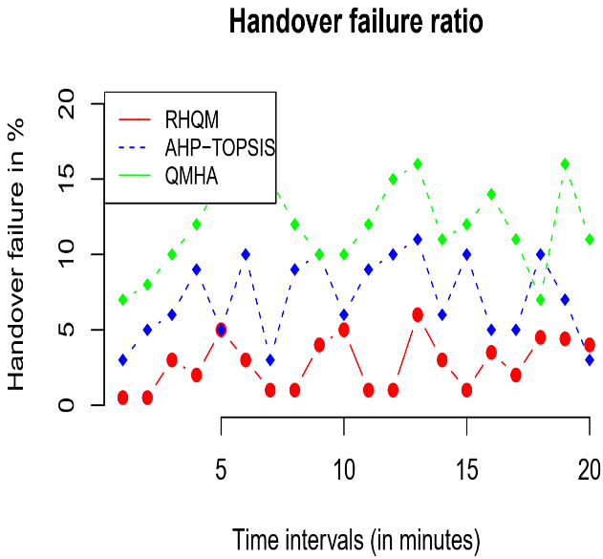

Fig.6.4: Handover-Failures perceived at divergent Intervals of Time

In Fig.6.4, QoS in the context of Handoff failures would be compared that notifies the RHQM has possessing minimum handoff failures; however, it is slightly unstable, but QMHA & AHP-TOPSIS exhibited unbalanced & maximum handoff failure ratio (HFR) that compared with proposed RHQM. The average HFR at distinct periods noticed that RHQM method is less than AHP-TOPSIS & QMHA in respective order.

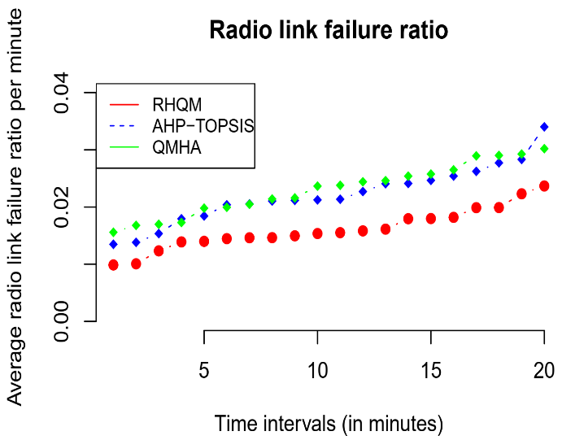

Fig.6.5: RLFR Noticed at distinct Time-Intervals

The observed radio links failure ratio (RLFR) for the proposed & other two existing models are exhibiting steady increment at distinct simulation intervals as compared in Figure 6.5. Nevertheless, the ratio of failure is minimum for the RHQM model, which is lesser than AHP-TOPSIS & QMHA in respective order.

**6.2 Results of MOAF:**

The experimental results obtained with the suggested strategy are examined using an LTE simulator [42]. The simulation parameters for the suggested strategy are shown in Table 2. In this scenario, there are 100 numbers of UEs and 10 numbers of eNBs. This simulation's traffic type is speed- and delay-sensitive, and it uses shadow fading based on a Gaussian log-normal distribution. The simulation process is completed in 2000ms.

Table 6.2: Proposed Method’s simulation parameters

|  |  |
| --- | --- |
| **Parameters** | **Assumptions** |
| Number of UEs | 100 |
| Number of eNB | 10 |
| Traffic type | Delay sensitive and speed sensitive |
| Shadow fading | Gaussian log-normal distribution |
| Frequency | 2GHz |
| Simulation time | 2000ms |

**6.2.1 Analysis of Performance:**

The performance of the MOAF-based HO scheme that is offered and the HO strategy put forth by Tanu Goyal and Sakshi Kaushal [20] are contrasted in this section. The comparison between the call block ratio and the eNB selection time is shown in Fig.6.6.

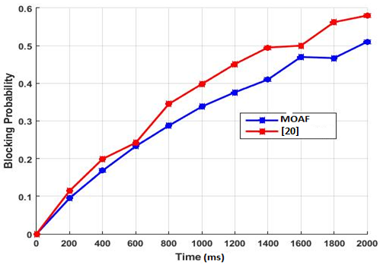

Fig.6.6: Call block ratio with eNB selection time

The call block ratio rises as the simulation time lengthens, as depicted in the image. However, the suggested MOAF based HO achieves better call block ratio when compared to the AHP-TOPSIS approach. Namely, the call block ratio of the proposed MOAF is 0.1 and that of AHP-TOPSIS is 0.12 at the simulation time of 200ms. Additionally, the suggested HO based MOAF system reduces the call block ratio to 0.51 at the simulation time of 2000ms as opposed to AHP-TOPSIS which achieves a call block ratio of 0.58. As this technique has high computational complexity, the call block ratio of the AHP-TOPSIS increases than the proposed HO based MOAF scheme.

The new HO scheme's call drop ratio is graphically compared to the current AHP-TOPSIS technique in Fig.6.7.

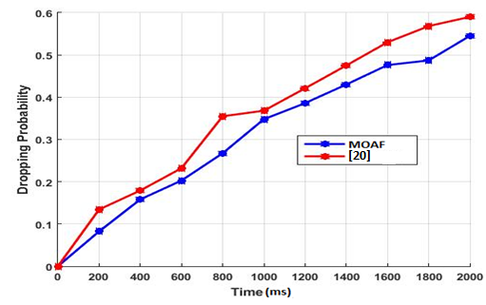

Fig.6.7: Call drop ratio with eNB selection time

The success rate of received calls rises as the target eNB is swiftly chosen using the suggested MOAF algorithm. So, the call drop ratio of the proposed MOAF scheme is reduced than that of the AHP-TOPSIS which attains 0.14 of call drop ratio while the proposed HO scheme attains 0.098 of call drop ratio at the simulation time of 200ms. Besides, the existing AHP-TOPSIS obtains 0.59 of call drop ratio but the proposed HO scheme obtains the 0.55 of call drop ratio at the simulation time of 2000ms.

The comparative analysis of HOF with selection time, including the suggested HO based MOAF scheme and AHP-TOPSIS, is shown in Figure 6.8.

**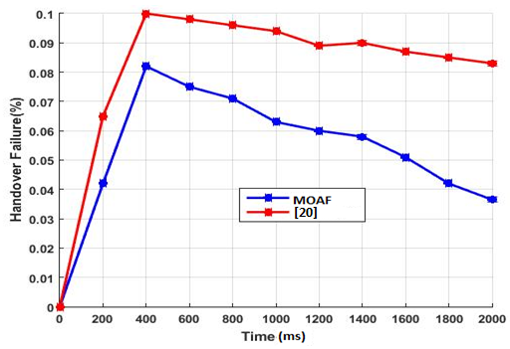**

Fig.6.8: HOF with eNB selection time

As shown in the figure, rate of HO failure attains the peak for both MOAF and AHP-TOPSIS based HO schemes at the simulation time of 400ms. However, compared to the AHP-TOPSIS, HO failure of the proposed MOAF based HO scheme is reduced to 20%. From the simulation time 400ms, HO failure of the HO scheme get decreases as shown in the figure. Nevertheless, HO failure of the proposed MOAF based HO scheme reduces to 54% than that of the existing AHP-TOPSIS at the simulation time of 2000ms.

The comparison of HOPP effect with selection time is shown in Fig.6.9. The target eNB's optimal selection will take longer because of the present AHP-TOPSIS's computational complexity. It causes a decrease in HO attempts. Therefore, with a simulation time of 2000ms, the effect of HOPP is reduced to 5% as compared to the current AHP-TOPSIS.

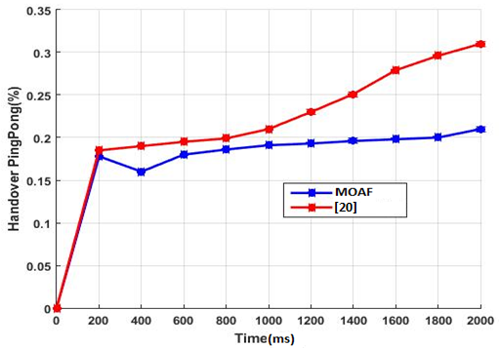

Fig.6.9: HOPP with eNB selection time

Besides, at the simulation time of 2000ms, HOPP of the proposed HO scheme is reduced to 33% than that of existing AHP-TOPSIS.

**6.3 Results of KGMO:**

The KGMO based mobility management system is implemented in MATLAB. The number of base stations and users are changed and performance evaluation is carried out. The network architecture is developed based on the LTE network standard to meet the real-time communication network criteria. The network throughput, delay, Number of Hand overs are the performance parameters for optimization of the algorithm and have been evaluated to analyze the overall performance of the network.

|  |
| --- |
| E:\works\GLT_works\Quest\kiran\matlab\results\nw_1.tif |
| Fig. 6.10: Network with Heterogeneous Model |

Network with heterogeneous model is represented in the Fig.6.10. The position of every user is identified from the and coordinates of the graph. Every network consists of the CH and each of the CH is connected to the base station. The users in the network are marked as small circles and these are connected to the cluster head. Table 6.3. Shows the specification of network which is used to simulate the proposed technique. Number of users is represented in N and cluster head as CH.

|  |  |  |
| --- | --- | --- |
| Table 6.3 Specification of network | | |
| 1 | No of users (N) | 50-100 |
| 2 | No of CH (NC) | 5-10 |
| 3 | User deployment Area | 50mx50m |
| 4 | Bandwidth (BW) | 20MHz |
| 5 | Cost Function | Minimum Distance |
| 6 | Optimization | KGMO |

**6.3.1 Analysis of Performance:**

The throughput analysis of the KGMO contemplated the bandwidth of the user with respect to the time. The throughput shown in Fig.6.11 indicates that the KGMO yields better performance compared with the existing PSO method.



Fig. 6.11**:** Overall Throughput Performance

The throughput calculation is done using the equation (6.1) [39]

(6.1)

MSS – Maximum Segment Size

RTT – Round Trip Time

p – Packet Loss

Cumulative throughput with respect to time is shown in Fig.6.12.Cumulative throughput is the cumulative addition of throughput value with respect to time for all stake holders of the network by taking the mean value. As the time increases the cumulative throughput for KGMO shows better performance compared to PSO method. Throughput of the system is calculated by taking the average of the throughput for different number of users.



Fig.6.12: Cumulative Throughput Performance

The average throughput for KGMO is 2.0317Mbps, whereas the average throughput for PSO is 1.4696Mbps. The improvement in throughput is (0.5621/2.0317) \*100 which is equal to 27%. After 80-100s only, the KGMO performance is highly better than PSO, before that particular time the throughput is average for both techniques. The reason is that the PSO easily falls into local optimum and has a low convergence rate in the iterative process.

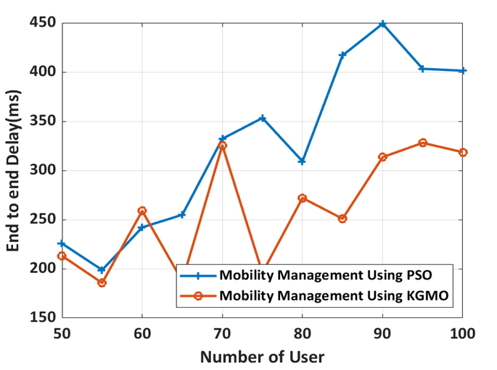

Fig. 6.13. End to end Delay vs Number of Users

Delay is the time taken by the system to connect Cluster Head to all the users under the corresponding CH. Over all Delay is the sum of all the Delays calculated in all the clusters. The delay occurred in connecting a user to a CH is not linearly related with number of users. This is due to the fact that distance between CH and users is not fixed and keeps changing with time at random. For example, the overall delay is 275ms when number of users are 80 and it is 250ms when the number of users is 85. The overall delay is less for KGMO method for the same number of users compared to PSO as shown in Fig.6.13



Fig. 6.14. Mean of End to end Delay vs Number of Users

Average of end-to-end delay is the cumulative addition of overall delay with respect to users of the network by taking the mean value. The mean value of end-to-end delay is less for KGMO method for the same number of users compared to PSO as shown in Fig.6. 14.



Fig. 6.15. Number of Handover Vs Number of User

Another performance parameter is number of handovers. It is one of the major factors which effects the performance of the network. For good performance, the number of handovers should be constant. From the Fig.6.15,it is observed that the number of handovers is relatively constant in the KGMO algorithm as compared to PSO.



Fig.6.16: Call drop ratio performance

The main causes of dropped calls in mobile networks are a lack of radio coverage, radio interference between customers, and flaws in network operation such as unsuccessful handover or cell-reselection efforts. So, in mobile networks, the call drop ratio is a crucial performance measure. From the Fig.6.16, the call drop ratio of the proposed KGMO scheme is reduced than that of the PSO, which attains 0.22 of call drop ratio while the proposed HO scheme attains 0.2 of call drop ratio at the simulation time of 500ms. Besides, the traditional PSO obtains 0.33 of call drop ratio but the proposed HO scheme obtains the 0.27 of call drop ratio at the simulation time of 2000ms.



Fig.6.17: Call block ratio performance

According to Fig.6.17, the call block ratio increases as the simulation time increases. However, the suggested KGMO based HO achieves better call block ratio when compared to the PSO. At a simulation time of 500 ms, the call block ratio of the proposed KGMO is 0.19, whereas that of the PSO is 0.22. Furthermore, compared to PSO, which achieves a call block ratio of 0.59, the suggested KGMO method reduces the call block ratio to 0.45 during the simulation time of 2000msDespite the high computational complexity of this method, the call block ratio of the PSO is higher than that of the suggested KGMO scheme.

**6.4 Comparison of Results:**

Table 6.4: Comparison of all three methods

|  |  |  |  |  |  |  |  |  |
| --- | --- | --- | --- | --- | --- | --- | --- | --- |
|  | RHQM | | | MOAF | | KGMO | | REMARKS |
| AHP TOPSIS | QMHA | RHQM | AHP TOPSIS | MOAF | PSO | KGMO | Selection time |
| HFR (%) | 2.80 | 6.80 | 0.50 | 0.10 | 0.08 | 0.08 | 0.06 | 400ms |
| 10 | 7.30 | 2.30 | 0.08 | 0.03 | 0.05 | 0.04 | 2000ms |
| CDR(%) | 2.40 | 2.74 | 1.80 | 0.17 | 0.15 | 0.18 | 0.16 | 400ms |
| 3.10 | 3.60 | 1.90 | 0.59 | 0.54 | 0.34 | 0.26 | 2000ms |
| CBR(%) | 1.20 | 1.50 | 0.90 | 0.20 | 0.17 | 0.20 | 0.17 | 400ms |
| 1.60 | 1.70 | 1.50 | 0.58 | 0.51 | 0.59 | 0.45 | 2000ms |
| Throughput  (Mbps) | 0.77 | 1.17 | 1.23 | 0.82 | 1.12 | 4.67 | 7.58 | 20s |
| 0.75 | 1.13 | 1.20 | 1.10 | 1.40 | 5.6 | 7.60 | 100s |

**6.5 Summary:** In order to select the optimal connection in heterogeneous LTE-based networks, a new mobility management strategy is provided in this work. a regression Heuristic methodology is used as a first model to provide the optimum connection management solution and consequently acquire performance metrics. To achieve handoff connection, optimization techniques have been selected as a second and third model with various metrics and simulation settings. Following extensive research and analysis, KGMO is determined to be the best option for upcoming technologies and generations to meet the QoS metrics.

**CHAPTER-7**

**CONCLUSION AND FUTURE SCOPE**

**Conclusion:**

The RHQM method derives regression heuristics that enable to scale of quality factors of the target cell in the handover process. The statistics of the quality metrics explored in this work, which buffers into the process log of the target cells, have considered as input values to the regression heuristics. These heuristics have used further to scale the fitness of the target cells towards the handoff process. The experimental study portrayed the significance of the proposed model RHQM that compared to the contemporary methods QMHA, and AHP-TOPSIS.

The MOAF algorithm-based HO scheme has been introduced in this research to improve resource management and smooth connection in the LTE-A network. The HO scheme's parameters have been calculated in each eNB prior to starting. By evaluating HO features, the MOAF algorithm determines the serving eNB HO to the target eNB that has been selected. In terms of HOF, call blocking ratio, HOPP, and call dropping ratio, the performance of the suggested strategy is assessed. According to simulation results, the MOAF HO scheme's HOF, chance of call drop, call block and HOPP are all lower than those of the current HO scheme by 12%, 6%, 5%, and 20%, respectively.

In this work, a new mobility management method is proposed to make network control more efficient in heterogeneous LTE-based networks. The KGMO optimization technique is used to make decisions for mobility management using network parameters such as location, distance, and velocity. The KGMO is aimed to improve performance metrics like Throughput, over all Delay and Number of Hand overs. These are evaluated based on Number of users and Cluster Heads. The KGMO is compared with PSO methodologies for evaluating these performance metrics. The throughput of the KGMO has been improved by about 27% over PSO method.

The call block ratio and call drop ratio of the KGMO technique and MOAF, as well as the throughput of the RHQM and MOAF, are calculated and compared in addition to the aforementioned performance metrics of the three methods.

**Future Scope:**

This work can be extended by using a hybrid optimization technique to reduce the calculation time. The RHQM's lessons for future research are to use these regression coefficients as fitness scales for evolution methods including genetic algorithms and differential evolution strategies, as well as to develop handoff-margins tuning. Also, handover precision can be improved by collecting the historical data of the user and base station followed by the data filtering process. Proper deep learning techniques can be applied to these data to perform a highly accurate decision-making process in less time. This can improve overall network performance.

**References:**

1. Ahmad, Rami, Elankovan A. Sundararajan, Nor E. Othman, and Mahamod Ismail. "Handover in LTE-advanced wireless networks: state of art and survey of decision algorithm." Telecommunication Systems 66, no. 3 (2017): 533-558.
2. Marabissi, D., Bartoli, G., Fantacci, R., Pucci, M.: An optimized CoMP transmission for a heterogeneous network using eICIC approach. IEEE Trans. Veh. Technol. 65(10), 8230–8239 (2016)
3. Li, Yun, Bin Cao, and Chonggang Wang. "Handover schemes in heterogeneous LTE networks: challenges and opportunities." IEEE Wireless Communications 23, no. 2 (2016): 112-117.
4. Sen, Jaydip. "Mobility and handoff management in wireless networks." arXiv preprint arXiv:1011.1956 (2010).
5. Samal, S.R., Bandopadhaya, S., Swain, K. and Poulkov, V., 2021. Mobility Management in Heterogeneous Cellular Networks. Journal of Mobile Multimedia, pp.407-426.
6. Bahra, N. and Pierre, S., 2021, June. A Hybrid User Mobility Prediction Approach for Handover Management in Mobile Networks. In Telecom (Vol. 2, No. 2, pp. 199-212). Multidisciplinary Digital Publishing Institute.
7. Qiu, Yue, Maode Ma, and Xilei Wang. "A proxy signature-based handover authentication scheme for LTE wireless networks." Journal of Network and Computer Applications 83 (2017): 63-71.
8. Tayyab, Muhammad, Xavier Gelabert, and RikuJäntti. "A survey on handover management: From LTE to NR." IEEE Access 7 (2019): 118907-118930.
9. Pokhrel, K., Dutta, N., Ghose, M.K. and Sarma, H.K.D., 2020. Performance analysis of various mobility management protocols for IPv6 based networks. International Journal of Computer Networks and Applications., 7(3), pp.62-81.
10. Su, Dongming, et al. "A self-optimizing mobility management scheme based on cell ID information in high velocity environment." 2010 Second International Conference on Computer and Network Technology. IEEE, 2010.
11. Komine, Toshihiko, Toshiaki Yamamoto, and Satoshi Konishi. "A proposal of cell selection algorithm for LTE handover optimization." 2012 IEEE Symposium on Computers and Communications (ISCC). IEEE, 2012.
12. Qian, Cen, Sihai Zhang, and Wuyang Zhou. "A novel cell selection strategy with load balancing for both idle and RRC-connected users in 3GPP LTE network." 2012 International Conference on Wireless Communications and Signal Processing (WCSP). IEEE, 2012.
13. Amzallag, David, et al. "Cell selection in 4G cellular networks." IEEE Transactions on mobile computing 12.7 (2013): 1443-1455.
14. Kamal, Archana, and Vineetha Mathai. "A novel cell selection method for LTE HetNet." 2014 International Conference on Communication and Signal Processing. IEEE, 2014.
15. Wang, Jun, et al. "Optimized fairness cell selection for 3GPP LTE-A macro-pico HetNets." 2011 IEEE vehicular technology conference (VTC Fall). IEEE, 2011.
16. Gao, Yuan, et al. "Performance of dynamic CoMP cell selection in 3GPP LTE system level simulation." 2011 IEEE 3rd International Conference on Communication Software and Networks. IEEE, 2011.
17. Zhu, Pengcheng, Lan Tang, and Bin Sheng. "Minimum SINR based dynamic cell selection scheme for LTE-advanced CoMP systems." Future Wireless Networks and Information Systems. Springer, Berlin, Heidelberg, 2012. 127-134.
18. Feng, Minghai, et al. "Enhanced dynamic cell selection with muting scheme for DL CoMP in LTE-A." 2010 IEEE 71st Vehicular Technology Conference. IEEE, 2010.
19. Hussein, Yaseein Soubhi, et al. "A novel cell-selection optimization handover for long-term evolution (LTE) macrocellusing fuzzy TOPSIS." Computer Communications 73 (2016): 22-33.
20. Goyal, Tanu, and Sakshi Kaushal. "Handover optimization scheme for LTE-Advance networks based on AHP-TOPSIS and Q-learning." Computer Communications 133 (2019): 67-76
21. Girma, Solomon T., and Abinet G. Abebe. "Mobility load balancing in cellular system with multicriteria handoff algorithm." Advances in Fuzzy Systems 2017 (2017).
22. Kalbkhani, Hashem, et al. "QoS-Based Multi-criteria Handoff Algorithm for Femto-Macro Cellular Networks." Wireless Personal Communications 98.1 (2018): 1435-1460.
23. Mamman, M., 2021. Call admission control algorithm with efficient handoff for both 4G and 5G networks. International Journal of Wireless & Mobile Networks (IJWMN) Vol, 13.
24. Lee, Chung-Nan, Jun-Hong Lin, Chih-Feng Wu, Ming-Feng Lee, and Fu-Ming Yeh. "A dynamic CRE and ABS scheme for enhancing network capacity in LTE-advanced heterogeneous networks." Wireless Networks 25, no. 6 (2019): 3307-3322.
25. Ramos-Cantor, Oscar D., JakobBelschner, GanapatiHegde, and Marius Pesavento. "Centralized coordinated scheduling in LTE-Advanced networks." EURASIP Journal on Wireless communications and Networking 2017, no. 1 (2017): 1-14.
26. Srikantamurthy, S.H. and Baumgartner, A., 2021, October. A Novel Unified Handover Algorithm for LTE-A. In 2021 17th International Conference on Network and Service Management (CNSM) (pp. 407-411). IEEE.
27. Manoj and Kumar, S., 2022. A proposed cell selection and handover optimization using TAOWOA in self-organized LTE networks. Journal of Interdisciplinary Mathematics, pp.1-20.
28. A. Slalmi, H. Chaibi, R. Saadane, A. Chehri, and G. Jeon, “5G NB-IoT: Efficient network call admission control in cellular networks,” Concurr. Comput. Pract. Exp., no. July, pp. 1–12, 2020, doi: 10.1002/cpe.6047.
29. Ye, J. and Zhang, Y.J.A., 2019. DRAG: Deep reinforcement learning based base station activation in heterogeneous networks. IEEE Transactions on Mobile Computing, 19(9), pp.2076-2087.
30. Purushothaman, K.E. and Nagarajan, V., 2021. Multiobjective optimization based on self‐organizing Particle Swarm Optimization algorithm for massive MIMO 5G wireless network. International Journal of Communication Systems, 34(4), p.e4725.
31. Gong, W., Pang, L., Wang, J. and Xia, M., 2019. PSO-based resource allocation in software-defined heterogeneous cellular networks. KSII Transactions on Internet and Information Systems (TIIS), 13(5), pp.2243-2257.
32. Wu, Xuehan, et al. "A Multi-objective Artificial Flora Optimization Algorithm." Simulation Tools and Techniques: 11th International Conference, SIMUtools 2019, Chengdu, China, July 8–10, 2019, Proceedings 11. Springer International Publishing, 2019.
33. Alhammadi, Abdulraqeb, et al. "Auto tuning self-optimization algorithm for mobility management in LTE-A and 5G HetNets." IEEE Access 8 (2019): 294-304.
34. Moein, Sara, and Rajasvaran Logeswaran. "KGMO: A swarm optimization algorithm based on the kinetic energy of gas molecules." Information Sciences 275 (2014): 127-144.
35. Rupp, Markus, Stefan Schwarz, and Martin Taranetz. "The Vienna LTE-advanced simulators." https://link. springer. com/book/10.1007% 2F978-981-10-0617-3 (2016).
36. Afroz, Farhana, et al. "SINR, RSRP, RSSI and RSRQ measurements in long term evolution networks." International Journal of Wireless & Mobile Networks (2015).
37. Lee, Changsung, Sungjin Shin, and Jong-Moon Chung. "Enhanced LTE handover scheme using NFV for LTE handover delay reduction." 2016 IEEE International Conference on Consumer Electronics-Asia (ICCE-Asia). IEEE, 2016.
38. Tanner, Roope. "Handover performance evaluation between 450 MHz and 2600 MHz LTE networks." (2016).
39. Soret B, Mogensen P, Pedersen KI, Aguayo-Torres MC. Fundamental tradeoffs among reliability, latency and throughput in cellular networks. *In2014 IEEE Globecom Workshops (GC Wkshps)* 2014 Dec 8 (pp. 1391-1396). IEEE

.

**LIST OF PUBLICATIONS**

1. Mannem, Kiran, P. Nageswara Rao, and S. Chandra Mohan Reddy. "Handover Decision in LTE & LTE-A based hetnets using regression heuristics of quality metrics (RHQM) for optimal load balancing." 2020 Fourth International Conference on Inventive Systems and Control (ICISC). IEEE, 2020. https://doi.org/10.1109/ICISC47916.2020.9171206
2. Mannem, Kiran, Pasumarthy Nageswara Rao, and S. Chandra Mohan Reddy. "Multi-Objective Artificial Flora Algorithm Based Optimal Handover Scheme for LTE-Advanced Networks." 2022 6th International Conference on Electronics, Communication and Aerospace Technology. IEEE,2022. https://doi.org/10.1109/ICECA55336.2022.10009271
3. Mannem, K., Rao, P.N. and Reddy, S.C.M. (2023) ‘High-performance mobility management using KGMO in heterogeneous network’, Int. J. Wireless and Mobile Computing, Vol. 24, Nos. 3/4, pp.235–242.https://doi.org/10.1504/IJWMC.2023.131308